NI Water Key Stage 2 poster competition
‘What lies beneath- flush out the sewer monsters’
Inspiration for Teachers
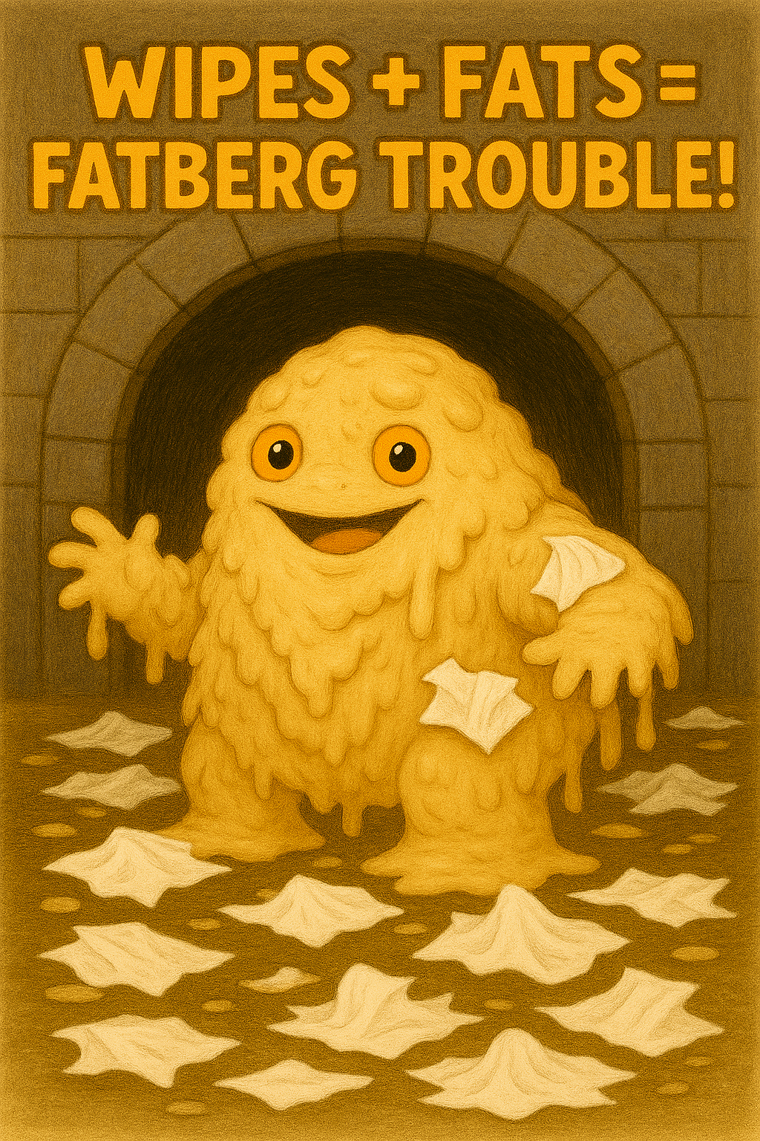

What lies beneath
Background Information
What is hidden in the sewers beneath your feet? Our flushing habits are having a monstrous impact on the network of pipes used to take away our wastewater. Fatbergs and Wet Wipe monsters are lurking, congealing and growing fast under our towns and cities across Northern Ireland and we need your help to stop these stinky menaces!!
Only you can help us catch and prevent these gross, smelly monsters from clogging up our sewers.
This year we asking pupils to draw a ‘WANTED’ poster for the monstrous fatbergs and wipe monsters. Design your own sewer monster, telling people who they are, how they were formed and how we can prevent them causing mayhem in our sewage systems.

What is a fatberg?
Sewers are designed only for water and the 3p’s: pee, poo and toilet paper but increasingly they are used as rubbish bins. The rubbish we dispose of down our sinks and toilets is creating monster sized blockages in our sewers we call FATBERGS.
Fatbergs are solid blobs in the sewers formed by a combination of ‘flushable’ non- biodegradable rubbish such as wet wipes and congealed grease and cooking fat.
When grease and fat are poured into the sewers they stick to the side of the pipes, wipes and other rubbish flushed down the toilet stick to this and it builds up layer upon layer of gunk like a slimy snowball effect!
Wipes don’t break down in the sewer system (no matter what they say on the packet) – they snag and knot together and cling to the grease deposits.
Wipes are a villain your toilet can’t defeat.

Problems Caused by Fatbergs
As more and more unflushables enter the sewers the more the fatberg grows until eventually it creates a major blockage!
Blockages mean NI Water’s sewer teams have to physically remove them which is an extremely difficult job in very challenging conditions.
Most sewers aren’t big enough for a person to enter so NI Water use high pressure jets and suction hoses to remove blockages – watch the video of our Jet Vac removing a huge blockage in a Belfast sewer last year. https://youtu.be/nwx-DDcXbbU?si=U3xOHbr7HGDkda18 ( please note the video references sanitary items: tampons and pads)
Removing blockages also cost lots of money.
If the sewage can’t reach our wastewater treatment works to clean it, it causes the sewers to overflow causing homes and streets to flood with sewage.
It can cause sewer water to flood into rivers and the environment causing pollution, harming plants and animals.

How to Prevent a Sewer Monster
- Don’t feed the fatberg: Don’t pour fat and grease down the sink. Keep a small container handy to pour fat and grease into before safely disposing in the bin
- Remember the 3 p’s Pee, Poo and toilet Paper, everything else will block the pipes.
- Many wipes are labelled flushable but they won’t break down. They make their way down the toilet but will eventually clog further along the pipes and spill into the environment.

How a Fatberg is Removed
Even though fatbergs are made of soft materials they are as tough as rocks! When trying to remove them it’s like trying to break concreate. Not only is it very expensive to remove but it’s extremely dangerous for the sewer workers, who have to wear special breathing apparatus and protective suits because of the dangerous gases released by the fatbergs.

Famous Fatbergs
- Some fatbergs are more than 800 feet long and weigh more than 4 hump backed whales!!
- 2017 a monster fatberg formed under Whitechapel in London. It was nicknamed Fatty McFatberg and weighed 130 tonnes – the same as 11 double decker buses.
- The museum of London put the 820 foot long (longer than 2 football pitches) fatberg on display
- It took 8 workers dressed in gas masks and protective suits to unblock the London Fatberg. They had to use high pressure hoses and pick axes to break the fatberg and suck up the pieces into tankers.
- A fatberg removed from the English seaside town of Sidmouth was a long as a Jumbo Jet.

Helpful Links
The Whitechapel Fatberg | London Museum

.

